**Preliminary Mission Trip Information**

**Preparation before you go**

*Passport can not expire within 6 months of when you will be returning from Uganda

*A single entry visa is $50. Submit online application if you have passport. You will receive it in your account and will have to print it and take with you.

**Vaccines required:**

*Yellowfever – this cost $118 (there is a form you have to show that is proof you got this when you arrive in Uganda) Mine was a lifetime shot. These have gotten difficult to get so start early to get it.

*Typhoid vaccine – these were pills I took (good for 5 years I think)

*Travelers Diarrea prescription filled

*Malaria medicine – I took these every day a week? Before I left, while I was gone and until 2 weeks after I returned. I think there were other options for this medicine. Mark took Doxycyclene

**Travel to Uganda**

Leave from Seattle Wednesday, September 4, 2019 on 5 p.m. flight (11 hours later in Uganda from Seattle)

Fly Emirates (currently flights are $1400 round trip)

*2 free checked bags with 50 lb limit

*We flew out of Seattle around 5 p.m. and arrived in Dubai around 8 pm the next day – about 13 hour flight with 3 meals served on flight. Every seat had its own screen and headphones to watch movies, listen to radio, t.v. or play games.

*I arrived in Dubai and hotel was included in flight I had so I took shuttle to hotel for my 12 hour layover. Hotel provided buffet for supper until midnight and buffet breakfast in morning all included. A bus tour of Dubai was offered from hotel from 9-11 p.m. for $30 so I did that.

*From Dubai to Entebbe was a 6 hour flight the next morning arriving in Uganda about 1 in afternoon.

**Draft Schedule** (very rough one to start)

Arrive in Kampala (Entebbe) on Friday, September 6 in afternoon

Spend night in Kampala

Saturday September 7 - Drive to Lira (about 6 hour drive north)

Sunday September 8 – Church visitation & participation

5 days – bibles and clothes and visits to remote villages

Other activities to be determined

Sunday 15th – drive to safari

Monday 16th – safari early morning until lunch then drive to Kampala

Tuesday 17th – souvenir shopping in Kampala

Wednesday 18th – leave for airport about noon and leave Entebbe around 4 p.m.

Arrive in Dubai in evening and get hotel overnight for 12 hour layover

Fly out of Dubai on Thursday morning and arrive back to seattle around noon of Thursday in Seattle

**Estimated Expenses**

1. Plane tickets about $1400
2. Accomodations - $80/day = $800 About
3. Meals per person – 12 days @ about $20/day = $240
4. Transportation for entire group - $? (This will have to be worked on, gas was expensive and it will depend how many people go with us how much a rental would be.)
5. Extra spending money – I took $300 and had them find best exchange rate there and exchange it. You have to have $100 bills that are newer than 2007? I think? I gave most of this money away to people I met. I didn’t buy many souvenirs but things are cheap in the markets. I got 2 african dresses handsewn and only paid $15 for one and maybe $30 for other.
6. I bought some gifts at the airport in Dubai.

**Estimated Summary:**

Plane tickets with insurance: $1400 - $1500

Extra Suitcase for supplies: $150

Lodging while there this includes hotel in

Kampala, Lira and the safari:

All Meals while there:

Transportation

While there: includes safari expense also

(This is the $1300 plus $300 deposit each to cover these things)

**Total High Estimate: $3300 each**

**Ministry Requests**

**Proposed budget for projects**

|  |  |
| --- | --- |
| Intended project s | Amount needed |
|  |  |
| 1. Bibles(each cost $10 ) we need 1000 | 10,000 (whatever number raised is appreciated ) |
| 1. Nutrition and childcare training | 1000 |

We’re flexible with the projects budget and we hope to fit within whatever the team is able to raise.

**Things helpful to them**

Because of our limit in weight for our suitcases some things are just better bought there. Also the more we are able to buy there the more it helps them there. The thing the people there need the most is not our stuff but skills and training to help them sustain themselves. To end poverty and dependency they need to be taught to work not given everything. Their thinking needs changed so they can support their own families. If we give them everything we are treating the symptoms not the problem. So giving tools, seeds or supplies to help is best. So things we did last time was teaching some women to sew diapers and we left the sewing machines. Also taught cake decorating and baking cakes and bought a stove for them to use and they now sell cake.

The focus is on the poor families and the starving children. kIds are naked with no shoes, diapers or clothes so we gave baby blankets and little shoes. We can help some of the extreme cases.

(Our biggest emphasis will need to be on getting money to purchase Bibles and food while there. 1000 Bibles are needed at $10 each)

$1000 in food can feed an entire village. It would feed a family for months

Mosquito nets can be bought there for $5-$8 each and this is a big need. Malaria was #1 killer there

Food boxes to people usually include soap, salt, oil, sugar

Backpacks even the string tie ones are a helpful thing for them to carry books especially in the rain. Many walk miles to get to school. Pencils are so helpful to them and little pencil sharpeners. Crayons are too hard to take and can be bought there.

Toothbrushes, toothpaste

Solar power chargers would be a big help there

Even old unlocked cell phones are something they really want. They buy their own sim card and insert it and buy minutes to put on it. We took laptops to give to some of the pastors who had nothing for studying.

**Facts**:

Uganda is about the size of Oregon, we have 3 million for population and they have 41 million. There are people everywhere.

The only airport in Uganda is Entebbe

It gets light at 7 a.m. and dark at 7 p.m. year round. It is right on the equator

December was the hottest time and was probably in the 90s while there. We were always somewhere with electricity but internet is not guaranteed. You have to take an adaptor for their plugs and sometimes electricity will be off in the night

If I could hook into internet, I would video chat with Mark or I would talk through WhatsApp. There are not a lot of places with free wifi and when in the villages there won’t be any and probably no electricity. Where will stay should have everything. The hotels were not the best western like here. Usually ceiling fans but no air conditioning and bathrooms you have to wear flip flops to keep from getting anything from water. You don’t want to walk in standing water.

I loved all the food there. Everything is always fresh and an expensive restaurant meal would be $10 so it is cheap there. In villages you will get rice and beans and some kind of meat like chicken, pork or beef among other things.

We wore dresses or skirts and get really dirty with all the dusty dirt roads. It is very bright there so avoid white skirts that will really be see through. When traveling or doing the safari we can wear capris. You won’t want jeans it is too hot and skirts are actually most comfortable with the heat. They don’t wear shorts so we just want to respect their culture. No short skirts or shorts and modest dress is best. Everything should at least come to your knees.

We have to be prepared to be called on to share at any time.

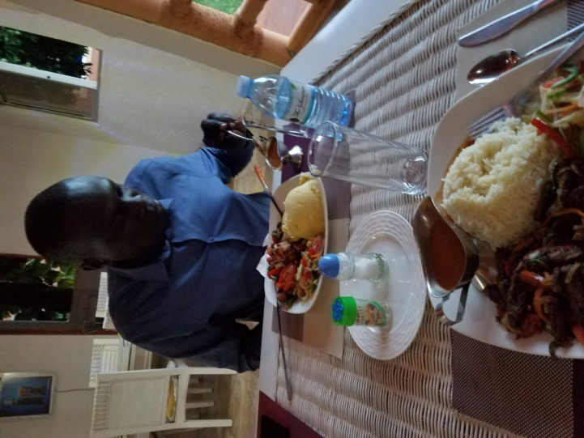

This is Michael and we ate at first hotel in Entebbe

Kids in the village get so excited when white people come some have never seen one. We bought fresh papaya from this lady, it was so good. We went toa little shop and bought these dresses

